**Introductions:**

Practitioner Advisors: Dave Karnowski

Peter Clark

Honorary Lifetime

Contact Member: Bob Thorn

Faculty Advisors: Dr. Melhem

Dr. Riding

**Officer Reports:**

President: Jennifer Sommerfeld

*jsommer@ksu.edu*

Vice President: Vincent Studer

*studerv@ksu.edu*

Treasurer: Carl Peterson

*cjpeters@ksu.edu*

Secretary: Claudia Gonzalez

*claudi1@ksu.edu*

Editor/Historian: Katie Walbridge

*katiewal@ksu.edu*

Freshman/Sophomore Rep: David Laurence

*davlaur@ksu.edu*

Activities/Projects Chair: Noura Saadi

*nsaadi@ksu.edu*

Steel Bridge Chairs: Robert Schweiger

*rschwei2@ksu.edu*

Cale Armstrong

*cagolf91@ksu.edu*

Concrete Canoe Chairs: Katlyn Dotson

*kattydid@ksu.edu*

Nathan Pohl

*pohl@ksu.edu*

Open House Chairs: Ben Nye

*nye@ksu.edu*

Nicholas Clow

*nickclow@ksu.edu*

**Agenda:**

Announcements: Jennifer Sommerfeld

Introduction of Speaker: Vince Studer

Speaker: Brian Clow

Carollo

In This Issue:

1. Tonight’s agenda

Sudoku

Important Information

1. Speaker Profile

ASCE Structure Profile

Schedule

Sudoku Answers

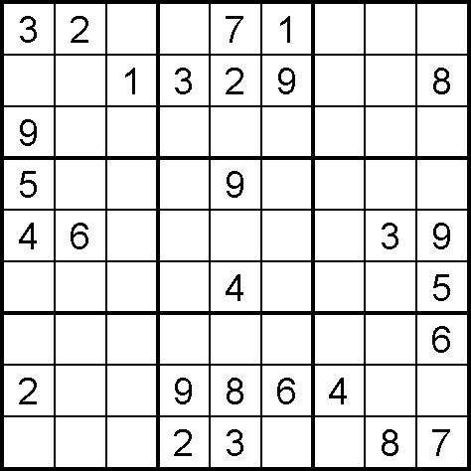

(Puzzle from Sudoku Collection:

www.sudokucollection.com)

Important Information

**FE Review** manuals are available for purchase with a discount promo code. Contact Carl Peterson if you are interested in purchasing the manual.

**Students must become national members to receive credit** for ASCE Student Membership. Registration is free and can be done online at http://www.asce.org/

Click “login” at the top of the page, then click “click here to create one” and follow the instructions to become a national member.



**Brian Clow**

**Carollo**

Brian has 25 years of experience in the planning and design of improvements to wastewater collection systems, pump stations, and wastewater treatment plants. He has designed all elements of wastewater treatment plants with an emphasis on preliminary treatment, primary treatment, biological treatment, and anaerobic digestion. Infrastructure projects include over 50 miles of large diameter gravity pipelines, tunneling, and pump stations.

Brian is a graduate of South Dakota State University, and is registered engineer in the States of Nebraska, Kansas, Missouri, Oklahoma, South Dakota, Colorado, and California. He is a board certified environmental engineer, and a certified wastewater treatment plant operator.

In his 25 year career he has worked on projects in California, Nevada, Colorado, South Dakota, Minnesota, Missouri, Oklahoma, Texas, and Kansas.



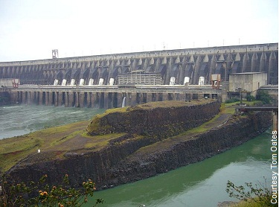

**Itaipu Dam**

Five-miles-wide and requiring enough concrete to build five Hoover Dams, the [Itaipu Dam](http://ga.water.usgs.gov/edu/hybiggest.html" \o "Itaipu Dam )spans the Parana River at the Brazil/Paraguay border. During its construction, workers shifted the course of the seventh largest river in the world by digging a 1.3-mile bypass. To accomplish this they had to remove 50 million tons of earth and rock.   
  
The main dam, as high as a 65-story building, is composed of hollow concrete segments; while the flanking wings are earth and rock fill. Enough iron and steel was used at Itaipu to build 300 Eiffel Towers. Another marvel of Itaipu is its powerhouse. Measuring one-half-mile long, it is partially submerged and contains 18 hydroelectric generators, each 53-feet across. Some 160-tons of water-per-second pour onto each turbine, generating 12,600-megawatts, enough to power most of California.   
  
Itaipu supplies 28 percent of all the electric energy in Brazil's south, southeast and central-west regions, and 72 percent of Paraguay's total energy consumption.

Information acquired from ASCE website, Seven Wonders

|  |  |  |  |
| --- | --- | --- | --- |
| October 17 | **Assembly** | Umberger 105 | 7:00 PM |
| October 26 | **FE EXAM** |  | TBD |
| November 7 | **Assembly** | Umberger 105 | 7:00 PM |
| November 14 | **Joint Dinner with KU** | Student Union |  |
| November 21 | **Assembly** | Umberger 105 | 7:00 PM |
|  |  |  | 7:00 PM |
|  |  |  |  |
|  |  |  | 7:00 PM |
|  |  |  | 7:00 PM |

Schedule