**Introductions:**

Practitioner Advisors: Dave Karnowski

Peter Clark

Honorary Lifetime

Contact Member: Bob Thorn

Faculty Advisors: Dr. Melhem

Dr. Riding

**Officer Reports:**

President: Jennifer Sommerfeld

*jsommer@ksu.edu*

Vice President: Vincent Studer

*studerv@ksu.edu*

Treasurer: Carl Peterson

*cjpeters@ksu.edu*

Secretary: Claudia Gonzalez

*claudi1@ksu.edu*

Editor/Historian: Katie Walbridge

*katiewal@ksu.edu*

Freshman/Sophomore Rep: David Laurence

*davlaur@ksu.edu*

Activities/Projects Chair: Noura Saadi

*nsaadi@ksu.edu*

Steel Bridge Chairs: Robert Schweiger

*rschwei2@ksu.edu*

Cale Armstrong

*cagolf91@ksu.edu*

Concrete Canoe Chairs: Katlyn Dotson

*kattydid@ksu.edu*

Nathan Pohl

*pohl@ksu.edu*

Open House Chairs: Ben Nye

*nye@ksu.edu*

Nicholas Clow

*nickclow@ksu.edu*

**Agenda:**

Announcements: Jennifer Sommerfeld

Introduction of Speaker: Vince Studer

Speaker: Brian Clow

Carollo

In This Issue:

1. Tonight’s agenda

Sudoku

Important Information

1. Speaker Profile

ASCE Structure Profile

Schedule

Sudoku Answers

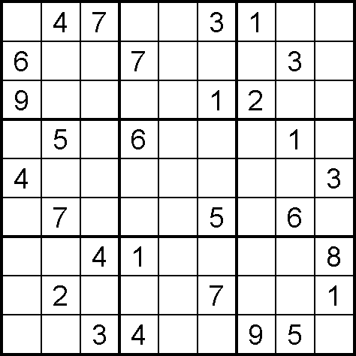

(Puzzle from Sudoku Collection:

www.sudokucollection.com)

Important Information

**FE Review** manuals are available for purchase with a discount promo code. Contact Carl Peterson if you are interested in purchasing the manual.

**Students must become national members to receive credit** for ASCE Student Membership. Registration is free and can be done online at http://www.asce.org/

Click “login” at the top of the page, then click “click here to create one” and follow the instructions to become a national member.



**Brian Clow**

**Carollo**

Brian has 25 years of experience in the planning and design of improvements to wastewater collection systems, pump stations, and wastewater treatment plants. He has designed all elements of wastewater treatment plants with an emphasis on preliminary treatment, primary treatment, biological treatment, and anaerobic digestion. Infrastructure projects include over 50 miles of large diameter gravity pipelines, tunneling, and pump stations.

Brian is a graduate of South Dakota State University, and is registered engineer in the States of Nebraska, Kansas, Missouri, Oklahoma, South Dakota, Colorado, and California. He is a board certified environmental engineer, and a certified wastewater treatment plant operator.

In his 25 year career he has worked on projects in California, Nevada, Colorado, South Dakota, Minnesota, Missouri, Oklahoma, Texas, and Kansas.

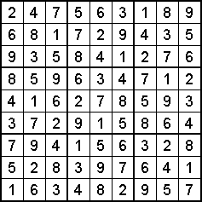

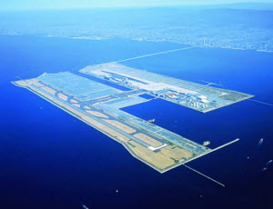

Kansai International Airport, Japan

Built and based in Osaka Bay, about three miles off the Japanese shore, Kansai International Airport features an extensive variety of user-friendly, modern amenities, including shopping areas, a children's playroom, an automated intra-airport transportation system, and a state-of-the-art ventilation system. Because of its location off shore, it is the only airport in the world that is able to function on a 24-hour basis without violating any noise regulations. The airport serves 24 cities in Japan with 69 departures daily and 71 cities in 30 other countries with 660 departures. Since it opened in September 1994, the annual number of international passengers using Kansai International Airport has increased from 2.5 million to more than 25 million.

References

" Kansai International Airport, " *Kansai International Airport, Japan*. N.p., n.d. Web. 01 Oct. 2013. <http://www.asce.org/People-and-Projects/Projects/Monuments-of-the-Millennium/Kansai-International-Airport%2C-Japan/>.

|  |  |  |  |
| --- | --- | --- | --- |
| October 17 | **Assembly** | Umberger 105 | 7:00 PM |
| October 26 | **FE EXAM** |  | TBD |
| November 7 | **Assembly** | Umberger 105 | 7:00 PM |
| November 14 | **Joint Dinner with KU** | Student Union |  |
| November 21 | **Assembly** | Umberger 105 | 7:00 PM |
|  |  |  | 7:00 PM |
|  |  |  |  |
|  |  |  | 7:00 PM |
|  |  |  | 7:00 PM |

Schedule