In This Issue:
- Tonight’s agenda
Sudoku
Important Information
- Introduction
CE Organizations/Eric Fitzsimmons
- Schedule for Fall 2014
Sudoku Answers

Introductions:
Practitioner Advisors: Dave Karnowski
Peter Clark
Honorary Lifetime
Contact Member: Bob Thorn
Faculty Advisors: Dr. Esmaeily
Dr. Riding
Officer Reports:
President: Vincent Studer
studerv@ksu.edu
Vice President: Claudia Gonzalez
claudi1@ksu.edu
Treasurer: Jacob Paperi
jpaperi@ksu.edu
Secretary: Bryan Harkrader
bhark@ksu.edu
Editor/Historian: Yadira Porras
yaporras@ksu.edu
Freshman/Sophomore Rep: Brett Morey
bmorey@ksu.edu Activities/Projects Chair: Mary Madden
marymadden@ksu.edu
Caleb Mitchell
caleb7@ksu.edu
Steel Bridge Chairs: Eric Hamilton
eric29@ksu.edu
Donald Powers
dlpowers@ksu.edu
Concrete Canoe Chairs: Jacquelyn Ewald
jkewald@ksu.edu
Darren Meyer
djmeyer@ksu.edu
Open House Chairs: Ben Nye
nye@ksu.edu
Koby Slaven
kslaven@ksu.edu
George Baker
georgefbaker@ksu.edu

Agenda:

Announcements: Vince Studer
Introduction of Speaker: Claudia Gonzalez
Speaker(s): CE Organizations
Eric Fitzsimmons

Important Information
Students must become national members to receive credit for ASCE Student Membership. Registration is free and can be done online at http://www.asce.org/
Click “login” at the top of the page, then click “click here to create one” and follow the instructions to become a national member.

If you are not currently enrolled in CE015, please do so in order to receive credit for attendance. Class Number: 10581

FE Review manuals are available for purchase. Contact Jacob Paperi if you are interested in purchasing the manual.

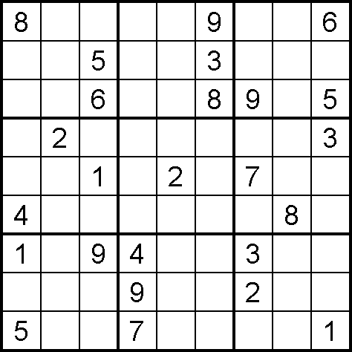

Netherlands North Sea Protection Works
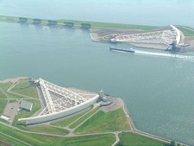

This singularly unique, vast and complex system of dams, floodgates, storm surge barriers and other engineered works literally allows the Netherlands to exist. For centuries, the people of the Netherlands have repeatedly attempted to push back the sea, only to watch brutal storm surges flood their efforts, since the nation sits below sea level and its land mass is still sinking. The North Sea Protection Works consists of two monumental steps the Dutch took to win their struggle to hold back the sea.

Step one, a 19-mile-long enclosure dam, was built between 1927 and 1932. The immense dike, 100-yards thick at the waterline, collars the neck of the estuary once known as Zuiderzee. Step two, the Delta Project, was intended to control the treacherous area where the mouths of the Meuse and Rhine Rivers break into a delta.

The project's crowning touch was the Eastern Schelde Barrier, a two-mile barrier of tell gates slung between massive concrete piers, which fall only when storm-waters threaten. The North Sea Protection Works exemplifies the ability of humanity to exist side-by-side with the forces of nature.

Eric J. Fitzsimmons, PhD

Dr. Fitzsimmons is a Visiting Assistant Professor in the Department of Civil Engineering at Kansas State University. He received his B.S., M.S., and Ph.D. degrees in Civil Engineering with a specialization in transportation from Iowa State University. During his graduate career, Dr. Fitzsimmons worked at the Institute for Transportation (InTrans) at Iowa State University and received training to specialize in highway safety, particularly in rural areas. Dr. Fitzsimmons worked closely with staff at the Iowa Department of Iowa (Iowa DOT) and developed many relationships with local road supervisors, and county engineers. His dissertation investigated horizontal curves and how drivers traverse through the curve by collected vehicle lateral position and speed data. The results of the dissertation found that there are distinct differences between drivers in urban areas and rural areas when traversing a curve. Through the research he assisted with, Dr. Fitzsimmons has made a substantial impact to roadway safety in both rural and urban areas. Dr. Fitzsimmons continued his highway safety work as a Post- Doctoral Researcher at the University of Kansas where he worked with the Kansas Department of Transportation on research to improve road safety in both urban and rural areas, specifically investigating low-cost countermeasures, crash analyses, and work zone safety. Dr. Fitzsimmons was award two FHWA Dwight D. Eisenhower Fellowships. He also won regional and local awards through the Institute of Transportation Engineers. Dr. Fitzsimmons is a member of the Transportation Research Board’s standing committees on Traffic Law Enforcement (ANB40), Operational Effects of Geometrics (AHB65), and Access Management (ANB70).

Sources:
*Sudoku puzzle from Sudokucollection.com
** http://www.asce.org/People-and-Projects/Projects/Seven-Wonders/Netherlands-North-Sea-Protection-Works/
September 4 | Assembly | Umberger 105
September 11 | Assembly | Umberger 105
October 2 | Picnic | TBA
October 9 | Assembly | Umberger 105
October 23 | Assembly | Umberger 105
October 30 | Assembly | Umberger 105
November 13 | Joint Dinner | KSU
November 20 | Assembly | Umberger 105
 | DATES SUBJECT TO CHANGE
DATES SUBJECT TO CHANGE

Schedule

2014 AMG STRUCTURAL
The AMG structural engineering scholarship:
Requirements:
- Enrolled as a full-time student
- Prove a GPA of 3.0 or higher
- Major in a field related to structural engineering
- Be involved in at least one extracurricular activity-including service groups, professional/engineering clubs, social societies, volunteer programs, or other noteworthy extracurricular involvement
Application due October 1st 2014 (See the KSU ASCE webpage bulletin board for more information!)

Scholarship Opportunity

Fold and tear here

---------------------------------------------------------------------------------------------------
Name: _________________________________________
Class Rank: FR SO JR SR (circle one)
Date: September 4, 2014

Student Member: Y / N (circle one)
National Member: Y / N (circle one)
National Number: _______________________

