In This Issue:

1. Tonight’s agenda

Sudoku

1. Important Information

Officer Contacts

Schedule

Sudoku Answers

**Introductions:**

Practitioner Advisors: Dave Karnowski

Peter Clark

Honorary Lifetime

Contact Member: Bob Thorn

Faculty Advisors: Dr. Melhem

Dr. Riding

**Officer Reports:**

President: Jennifer Sommerfeld

Vice President: Vincent Studer

Treasurer: Carl Peterson

Secretary: Claudia Gonzalez

Editor/Historian: Katie Walbridge

Freshman/Sophomore Rep: Logan Nichols

Activities/Projects Chair: Noura Saadi

Steel Bridge Chairs: Rober Schweiger

Cale Armstrong

Concrete Canoe Chairs: Katlyn Dotson

Nathan Pohl

Open House Chairs: Ben Nye

Nicholas Clow

**Agenda:**

Announcements: Jennifer Sommerfeld

Introduction of Speaker: Vince Studer

Speaker: CE Organizations/ Advisors

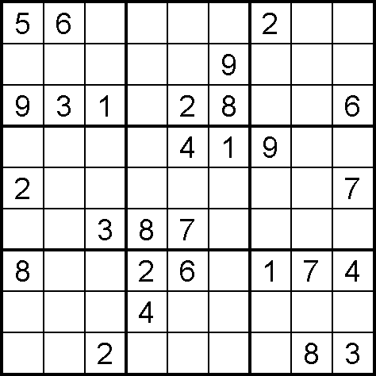

(Puzzle from Sudoku Collection:

www.sudokucollection.com)

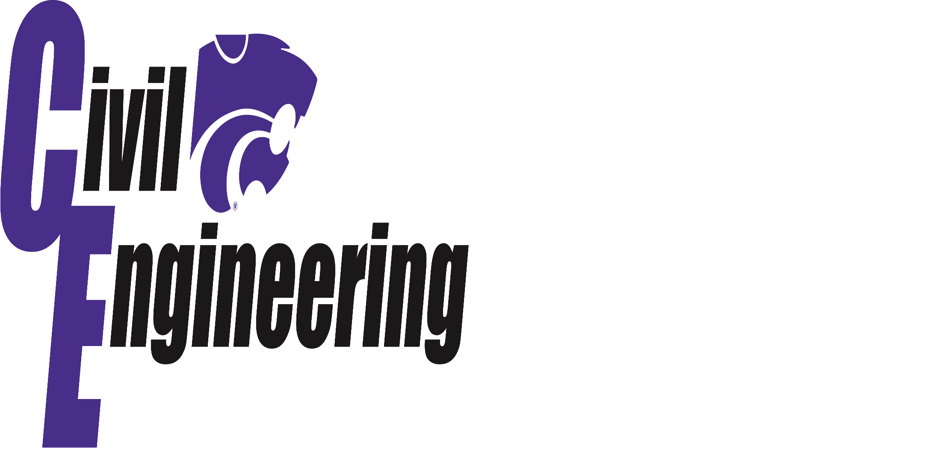

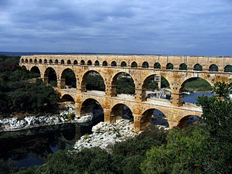

**Roman Aqueducts**

The Roman Empire used technology that changed the history of the world. One of their many technologies was the use of aqueducts. These aqueducts were responsible for providing the Roman Empire with water. Water was then used for supplying public baths, latrines, fountains and private households. At the height of the Roman Empire, the empire’s population was approximately 1,000,000 people. The aqueducts were capable of delivering up to one cubic meter of water per person.

The aqueducts were designed on the simple idea of gravity. Water was transported from higher elevations to lower elevations. To transport through valleys or lowlands the Romans built aqueducts on bridges with arches, which is the image that most people think of when they hear Roman Aqueducts. However, must of the aqueducts were buried following the natural lay of the land.

Mark Williams, PE

Central Division Aviation Market Sector Leader

HNTB

Mark Williams graduated from Garden City High School before attending Kansas State University.  While at KSU, Mark was a member of Lambda Chi Alpha fraternity and participated in activities with the Civil Engineering Department, including Chi Epsilon.  After graduating in 1992 with a BSCE, he began his aviation design career with BWR in Kansas City where he was both a Resident Engineer and Design Engineer.  
  
After 5 years with BWR, he accepted a role with HNTB and still works for HNTB in their Overland Park office.  He is currently the Central Division Aviation Market Sector Leader.  He works with numerous HNTB offices to build the firm's aviation practice.  Mark is a licensed Professional Engineer in four states: KS, MO, IA and TX.  While with HNTB, Mr. Williams has been involved with projects at six of the ten busiest airports in the United States.  
  
Mark has been married to his wife Denise, whom he met at K-State, for 18 years.  She is a Manhattan native.  They have two children: Callie who is 14 and Jaren who is 12.  They are proud football season ticket holders, Mark and Denise for 25 years now, and both children since they were born.  
  
Currently, Mark is also the President for the Kansas Society of Professional Engineers, a youth coach, past Sunday School teacher and enjoys working out, reading and golf.

Officer Contacts

Important Information

**President:**

Jennifer Sommerfeld – *jsommer@ksu.edu*

**Vice President:**

Vince Studer –*studerv@ksu.edu*

**Treasurer:**

Carl Peterson – *cjpeters@ksu.edu*

**Secretary:**

Claudia Gonzalez – *claudi1@ksu.edu*

**Editor/Historian:**

Katie Walbridge – *katiewal@ksu.edu*

**Fresh/Soph Rep:**

Logan Nichols – logan94*@ksu.edu*

**Activities/Projects Chair:**

Noura Saadi – *nsaadi@ksu.edu*

**Steel Bridge Chairs:**

Robert Schweiger – *rschwei2@ksu.edu*

Cale Armstrong *– cagolf91@ksu.edu*

**Concrete Canoe Chairs:**

Katlyn Dotson –*kattydid@ksu.edu*

Nathan Pohl – *npohl@ksu.edu*

**Open House Chairs:**

Benjamin Nye – nye@ksu.edu

Nicholas Clow – *nickclow@ksu.edu*

**FE Review** manuals are available for purchase with a discount promo code. Contact Carl Peterson if you are interested in purchasing the manual.

**Students must become national members to receive credit** for ASCE Student Membership. Registration is free and can be done online at http://www.asce.org/

Click “login” at the top of the page, then click “click here to create one” and follow the instructions to become a national member.

|  |
| --- |
| Schedule |

|  |  |  |  |
| --- | --- | --- | --- |
| September 5 | **CE Clubs/Advisors** | Umberger 105 | 7:00 PM |
| September 12 | **Fall Picnic** | Goodnow Park | TBD |
| September 19 | **Sega Inc.** | Umberger 105 | 7:00 PM |
| October 3 | **Assembly** | Umberger 105 | 7:00 PM |
| October 17 | **Assembly** | Umberger 105 | 7:00 PM |
| October 26 | **FE EXAM** |  |  |
| November 7 | **Assembly** | Umberger 105 | 7:00 PM |
| November 21 | **Assembly** | Umberger 105 | 7:00 PM |

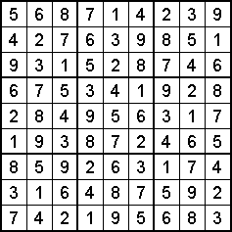

(Puzzle from Sudoku Collection:

www.sudokucollection.com)