Welcome to Assembly

September 3, 2009

In This Issue:
- Tonight’s agenda:
Speaking: Josh Lipscomb & Lauren Brown of BHC Rhodes
- Professor Profile: Dr. Riding
- CE 015 Grading Procedures
- Welcome New Students!
- Announcements
- Fall 2009 Officer Contacts
Sudoku Answer


Tonight:
Introductions:
Practitioner Advisors: Dave Karnowski
Earl Tast
Honorary Lifetime
Contact Member: Bob Thorn
Faculty Advisors: Dr. Riding and Dr. Hossain

Officer Reports:
President: Jake Ferrell
Vice President: Wesley Nyberg
Treasurer: Paul Fangman
Recording Secretary: Nathan Whitcomb
Corresponding Secretary: Jessalyn Fischer
Newsletter Editor: Becca Nyght
Historian: Cody Cates
Student Council Rep: Rachel Spicer
Freshman/Sophomore Rep: Walter Hicks
Graduate Student Rep: Steven Hammerschmidt
Activities Chair: Michael Heigert
Special Projects Chair: Tom Greer
Open House Chairs: Kait Howard
Elaine Lamm
Steel Bridge Chairs: Kurt Hershey
Trevor Fenton
Concrete Canoe Chairs: Amanda Sixbury
Webmaster: Terrance Dobbins

Agenda:

Announcements: Jake Ferrell
Introduction of Speaker: Wesley Nyberg
Speakers: Josh Lipscomb & Lauren Brown
Topic: “Career Path Options”

Did you Know?
The Empire State Building contains 60,000 tons of steel, more than 10 million bricks, and has 6,500 windows.

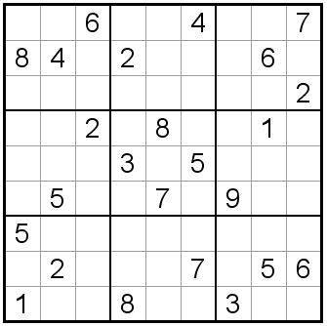

Welcome Back!

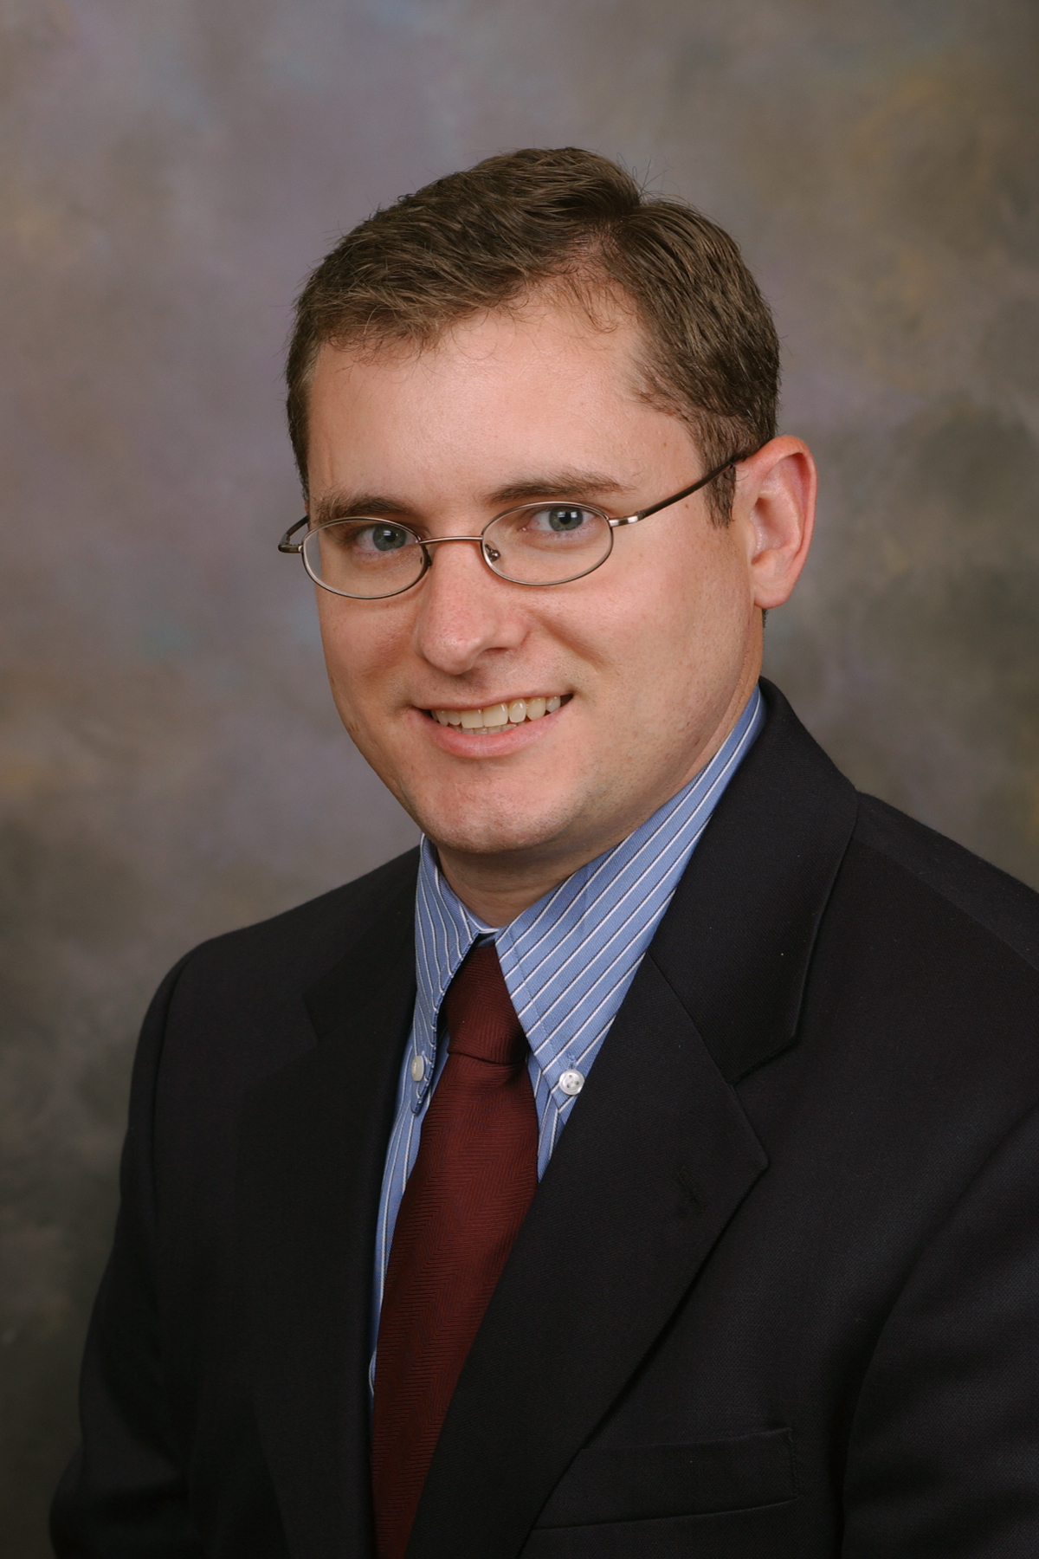

Kyle Riding
Assistant Professor
2107 Fiedler Hall
riding@ksu.edu

Dr. Riding was born in Baltimore, Maryland and raised in Fresno, California. He obtained a Bachelors degree in Civil and Environmental Engineering from Brigham Young University in Provo, UT in 2002. After attending BYU, he began graduate school at the University of Texas at Austin, with an emphasis on civil engineering materials in the structural engineering group. He received a Master’s of Science in Engineering degree in 2004 and a Ph.D. in 2007 from the University of Texas at Austin. During his graduate studies at the University of Texas at Austin, he worked as a graduate research assistant at the Concrete Durability Center on developing tools to help prevent mass concrete cracking. This work received a Top Research Innovations and Findings Award from the Texas Department of Transportation in 2005. After graduation from the University of Texas at Austin, he worked for one year as a postdoctoral researcher at the Laboratory of Materials of Construction at the Swiss Federal Institute of Technology at Lausanne to determine the mechanism of cement early age strength enhancement by certain proprietary chemical admixtures.

Dr. Riding’s research focuses on how to build more durable, constructible, and cost effective concrete infrastructure by better linking material properties with their in-place performance. This includes better understanding of the interaction with structures and the environment, and developing tools to select compatible materials and construction techniques. He is very involved in the American Concrete Institute, and is a voting member of the Properties of Concrete at Early Ages committee and an associate member of the Durability of Concrete committee.

Dr. Riding is married to the former Marci Ebert and has two beautiful daughters. Rachel is 5 years old and Annie is 3 years old.

CE 015: CIVIL ENGINEERING ASSEMBLY – Fall 2009

COURSE DESCRIPTION. Civil Engineering Assembly provides a broad introduction to the Civil Engineering profession. Topics covered include career opportunities in Civil Engineering, professional and ethical responsibilities of the engineer, the importance of professional licensure and the need for lifelong learning and continuing education. The course provides social activities and opportunities to develop leadership skills through involvement in the Kansas State University Student Chapter of the American Society of Civil Engineers (ASCE). CE 015 is a required, 0 credit hour course.

COURSE FORMAT. The meetings and activities of CE 015 are planned and conducted by the officers of the K-State Student Chapter of ASCE, under the direction of the course instructors.

COURSE INSTRUCTORS. Dr. Kyle Riding, Ph.D., Assistant Professor of Civil Engineering
Phone: 532-1578, email: riding@ksu.edu
Dr. Mustaque Hossain, Ph.D., P.E., Professor of Civil Engineering
Phone: 532-1576, email: mustak@ksu.edu

COURSE OBJECTIVES (EXPECTED OUTCOMES). The goal of CE 015 is to provide students with a broad understanding of the Civil Engineering profession. Specifically, each student is expected to develop an understanding of the following aspects of the Civil Engineering profession:
1. Basic areas of specialization and potential career paths in Civil Engineering.
2. Significant historical developments and contemporary issues in Civil Engineering.
3. The local and global social, economic, environmental, and public safety aspects of Civil Engineering projects.
4. The professional and ethical responsibilities of the engineer.
5. The importance of active involvement in ASCE.
6. The importance of professional licensure.
7. The need for lifelong learning and continuing education.
8. The importance of teamwork in engineering practice.

COURSE ASSESSMENT METHODS (GRADING). All Civil Engineering students are required to enroll in and earn credit for CE 015 in each semester of their Civil Engineering Program of Study. The penalty for failure to meet the requirements for CE 015 is the same as that of any other required course.
To earn credit for CE 015, students who are not members of the K-State Student Chapter of ASCE must attend a minimum of five CE 015 assembly meetings, or attend a minimum of four assembly meetings and actively participate in at least one of the following activities:
1. ASCE Concrete Canoe Team.
2. ASCE Steel Bridge Team.
3. College of Engineering Open House.
4. “Other” activities as approved by the course instructors.

Members of the K-State Student Chapter of ASCE must attend a minimum of four CE 015 assembly meetings, or attend a minimum of three assembly meetings and actively participate in at least one of the four activities listed above.

COURSE SCHEDULE. The schedule of CE 015 meeting dates and ASCE Student Chapter activities is available at the following locations: the bulletin board in the Bruce Butler Atrium (second floor of Fiedler Hall); the ASCE student Chapter Newsletter (available at all CE 015 meetings); and the K-State ASCE Student Chapter website.∗ In addition, meeting announcements are posted throughout the College of Engineering Building Complex and other buildings frequently used by engineering students. Meeting announcements are also disseminated through electronic mailings.
∗ K-State Student Chapter website: www.engg.ksu.edu/ASCE

Welcome, New Students!

Grant Bangerter
Spencer Benlon
Michael Berg
Joel Bland
David Chilson
Austin Conrady
Aaron Cossel
Cory Cotton
Bradley Deppen
Dalen Dickerson
Timothy Ditch
Katlyn Dotson
James Ewing
James Ferm
Chase Galle
Ben Gasper
Tom Geeslin
Rebecca Greif
Joe Harrington
Michael Jackman
Trevor Kaufman
Robert Kessler
Javan Koehn
James Kozak
Brianna Krysztof
Dominic LaRocca
Jarray Lee
Samuel Linan
Cody Loose
Eric Lovich
Ryan Lund
Jesse Madsen
Ben McCoy
Nick McGee
Michael Mesa
Pritchard Mhere
Colin O’Leary
Charles Page
Megan Peterson
Vincent Praderio
Kory Rankin
Scott Reed
Robert Reilly
Josh Riley
Taylor Robillard
Alexander Roe
Chris Rottinghaus
Ken Sabourin
Derrick Schmitz
Honora Shanno
Joe Shaw
Taylor Smith
Andrew Spencer
Trevor Steinbrock
Mark Stewart
Jenny Swabb
Jordan Swoyer
Jordan Thompson
Zach Weaver
Nate Wold
Robee Ybanez

Announcements:

- KSU ASCE Logo Contest!
  - Winner gets a $200 gift certificate to Best Buy.
  - Rules and Regulations:
    - Prospective logo’s can use the Powercat or any other KSU logo’s as long as it preserves the integrity of the K-State logo.
    - All logo’s will be subject to approval of the college upon entry into the contest.

- If you are interested in joining Steel Bridge this year, please contact Kurt Hershey (khershey@ksu.edu) or Trevor Fenton (trevorf@ksu.edu).

- If you are interested in joining Concrete Canoe this year, please contact Amanda Sixbury (mandasix@ksu.edu)

- K-State ASCE members beat KU ASCE members at the softball event this past Saturday. Final Score: 14-10.

- If you are interested in purchasing an ASCE membership, please contact Paul Fangman (pfangman@ksu.edu). Memberships are $10 for one semester and $15 for a year.
  - Memberships count towards one assembly credit for the semester.
  - Being a student member allows you to register to become a national member of ASCE. If you are interested in becoming a national member, please visit www.asce.org/membership.

- Open House rules will be posted later this fall. This is a perfect activity for new members looking to get involved or for old members wanting to add to their resumes. Stay tuned for ways you can help the Civil Department sweep Open House this year!

- If you are not currently enrolled in CE015, please do so in order to receive credit for attendance.
  - Class Number: 11612

- The All-University Career Fair will take place on Tuesday, September 22, 2009: Employers A-J and on Wednesday, September 23, 2009: Employers K-Z.
  - Place: Bramlage Coliseum
  - Time: 11:00 AM – 4:00 PM

Feel free to send comments and suggestions for the newsletter to: rnyght@ksu.edu

Remaining Schedule Fall 2009

September 17, 2009
Nyloplast
*Assembly
Fiedler 1107 at 7:00 PM

September 24, 2009
*ASCE Picnic
Place: TBA
Time: TBA

October 8, 2009
APWA
*Assembly
Fiedler 1107 at 7:00 PM

October 22, 2009
Olsson Associates
*Assembly
Fiedler 1107 at 7:00 PM

November 5, 2009
*KU-KSU Joint Dinner
Place: TBA
Time: TBA

November 19, 2009
*Assembly
Fiedler 1107 at 7:00 PM

December 10, 2009
Senior Presentation
*Assembly
Fiedler 1107 at 7:00 PM

FALL 2009 ASCE OFFICERS
OFFICE | NAME | E-MAIL
President | Jake Ferrell | ferrell@ksu.edu
Vice President | Wesley Nyberg | wnyberg@ksu.edu
Treasurer | Paul Fangman | pfangman@ksu.edu
Corresponding Secretary | Nathan Whitcomb | whitcomb@ksu.edu
Recording Secretary | Jessalyn Fischer | jrf7998@ksu.edu
Newsletter Editor | Becca Nyght | rnyght@ksu.edu
Historian | Cody Cates | ccates@ksu.edu
Stu-Co Rep. | Rachel Spicer | rspicer@ksu.edu
Fresh/Soph Rep. | Walter Hicks | whicks@ksu.edu
Graduate Student Rep. | Steven Hammerschmidt | hammer@ksu.edu
Activities Chair | Michael Heigert | mheigert@ksu.edu
Special Projects Chair | Tom Greer | tmgreer@ksu.edu
Webmaster | Terrance Dobbins | terrance@ksu.edu
Open House Chairs | Kait Howard | kait2@ksu.edu
 | Elaine Lamm | elamm@ksu.edu
Concrete Canoe Chair | Amanda Sixbury | mandasix@ksu.edu
Steel Bridge Chairs | Kurt Hershey | khershey@ksu.edu
 | Trevor Fenton | trevorf@ksu.edu

