In This Issue:

1. Tonight’s agenda

Sudoku

Important Information

1. Speaker Profile

Structure Profile

1. Scholarships/Internships

Schedule

Sudoku Answers

**Introductions:**

Practitioner Advisors: Dave Karnowski

Peter Clark

Honorary Lifetime

Contact Member: Bob Thorn

Faculty Advisors: Dr. Melhem

Dr. Riding

**Officer Reports:**

President: Jennifer Sommerfeld

*jsommer@ksu.edu*

Vice President: Vincent Studer

*studerv@ksu.edu*

Treasurer: James Scott

*jamesds@ksu.edu*

Secretary: Michael Stancic

*sumadinac316@ksu.edu*

Editor/Historian: Claudia Gonzalez

*claudi1@ksu.edu*

Freshman/Sophomore Rep: Yadira Porras

*yaporras@ksu.edu* Activities/Projects Chair: Noura Saadi

*nsaadi@ksu.edu*

Steel Bridge Chairs: Robert Schweiger

*rschwei2@ksu.edu*

Cale Armstrong

*cagolf91@ksu.edu*

Concrete Canoe Chairs: Katlyn Dotson

*kattydid@ksu.edu*

Nathan Pohl

*pohl@ksu.edu*

Open House Chairs: Ben Nye

*nye@ksu.edu*

Nicholas Clow

*nickclow@ksu.edu*

Caleb Mitchell

*caleb7@ksu.edu*

**Agenda:**

Announcements: Jennifer Sommerfeld

Introduction of Speaker: Vince Studer

Speaker(s): Ryan McGrath

Engineers Without Borders

WSCL Attendees

Important Information

**Students must become national members to receive credit for ASCE Student Membership.** Registration is **free** and can be done online at http://www.asce.org/

Click “login” at the top of the page, then click “click here to create one” and follow the instructions to become a national member.

**If you are not currently enrolled in CE015, please do so in order to receive credit for attendance. Class Number: 10581**

**FE Review** manuals are available for purchase. Contact James Scott if you are interested in purchasing the manual.

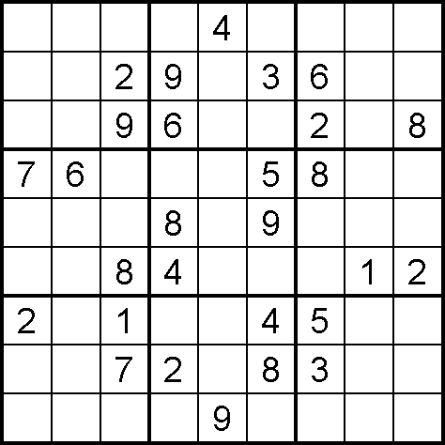

*



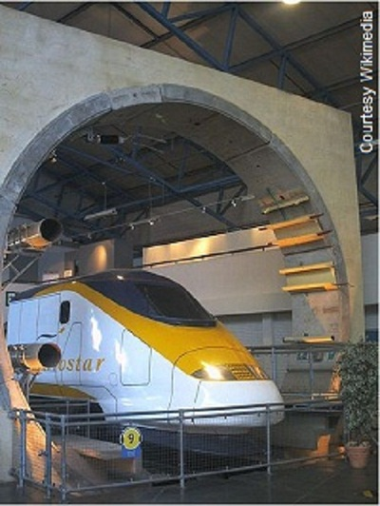

**Channel Tunnel**

The 31-mile [Channel Tunnel](http://www.asce.org/Featured-Images/Channel-Tunnel/)(Chunnel) fulfilled a centuries-old dream by linking Britain and the rest of Europe. More than a tunnel, it combines infrastructure and immense machinery in an underwater system of unprecedented ambition. Three 5-feet thick concrete tubes plunge into the earth at Coquelles, France, and burrow through the chalky basement of the English Channel. They reemerge behind the white cliffs of Dover at Folkstone.   
  
Through two of the tubes rush the broadest trains ever built. The double decker behemoths, which span 14-feet across, traverse the tunnel at close to 100 mph. Passengers board not on foot, but in automobiles and buses. Maintenance and emergency vehicles utilize the third tunnel, located between the rail tubes.   
  
Huge pistons open and close ducts, relieving the pressure that builds ahead of the trains' noses. Some 300 miles of cold water piping run alongside the rail tracks to drain off the heat raised by the air friction. **

**Ryan McGrath, PE,**

Instructor

**Ryan McGrath** is a registered professional engineer with 17 years of experience with water resources engineering, surveying and GPS technologies. Ryan received his Bachelors in civil engineering from the University of Hawaii and his Masters from the University of Colorado- Boulder. Mr. McGrath teaches Elementary and Advanced Surveying, Engineering Graphics, and Water Resources and is a factory-certified trainer for Trimble Navigation on GPS technologies. In addition to teaching, Mr. McGrath specializes in in-channel topographic and bathymetric survey for river channel mapping and hydraulic analysis and floodplain modeling.

**Engineers Without Borders**

Engineers Without Borders (EWB) is a non-profit, volunteer organization dedicated to creating a more stable and prosperous world by addressing people's basic human needs by providing necessities such as clean water, power, sanitation and education. EWB is the catalyst for a new movement to educate the next generation of socially conscious engineers deeply aware of the needs of the rest of the world

For more information:

Contact President Brendan Bishop at [bishop36@k-state.edu](mailto:bishop36@k-state.edu)

**Enter for a chance to win a FREE TEXTBOOK!** All you have to do is:

1) Email 3 interesting facts about yourself (one being why you chose to major in Civil Engineering) to

[**yaporras@k-state.edu**](mailto:yaporras@k-state.edu)**.**

2) If chosen, attend the assembly to present your three facts.

All those who participate in the “Student Spotlight” will be entered in a drawing to win a free textbook for the 2014 Fall semester! The drawing will take place on the last assembly of the semester.

**Scholarships**

*March 1st, 2014:*

* Kansas Chapter of the American Concrete Institute 2014 Scholarship
* 2014 National Daniel W. Mead Student Contest

*May 1st, 2014:*

* Kansas Chapter of the American Public Works Association: Steve Webb Memorial Scholarship

Applicants must be enrolled as an undergraduate student at Kansas State University in a curriculum which could possibly lead to a career in Public Works. Preference will be given for Civil Engineering students.

Applicant must be in good academic standing with respect to the requirements established by the School of Engineering at the University.

Applicant must be classified as a junior or senior for the year in which they receive the scholarship and must be enrolled in a minimum of 12 credit hours each semester.

**Internships/Jobs**

[Riley County Summer Internship](http://www.rileycountyks.gov/jobs)

GBA

**For more information on these scholarships and internships, visit** [**http://www.engg.ksu.edu/asce/**](http://www.engg.ksu.edu/asce/) **and click on the “Bulletin Board” tab.**

Schedule

Scholarships/Internships

**Sources:**\*Sudoku puzzle from sudokucollection.com   
** http://www.asce.org/People-and-Projects/Projects/Seven-Wonders/Channel-Tunnel/

|  |  |  |
| --- | --- | --- |
|  |  |  |
| February 20 | **Assembly** | Umberger 105 |
| March 6 | **Assembly** | TBA |
| March 11 | **Tour** | Water Treatment  Plant |
| April 4-5 | **Open House** |  |
| April 17 | **Assembly** | TBA |
| May 1 | **Assembly** | TBA |
|  |  |  |

**DATES SUBJECT TO CHANGE**

|  |  |
| --- | --- |
|  |  |

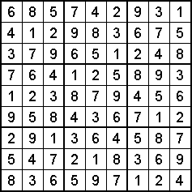

**Have suggestions/ideas on how to improve your ASCE chapter or newsletter?**

Contact Claudia Gonzalez at [claudi1@ksu.edu](mailto:claudi1@ksu.edu) or any of the other officers listed on page 1.