**Option of Shortening Period of Performance from 5 Years to 3 Years**

**Revised Work Plan for CERCLA Section 104(k)(7) Cooperative Agreement**

**TR-84027001**

**FY21 Technical Assistance to Brownfields (TAB) Communities**

**Geographical Areas 5, 6, 7, 8 & 11**

Center for Hazardous Substance Research

Kansas State University ▪ Manhattan, KS

March 28, 2022

At the request of the EPA, KSU agrees to reduce the Period of Performance (POP) of this Work Plan from 5 years to 3 years, if needed, to meet higher levels of brownfields activities and funding in the coming years. Shortening the POP will allow for a higher yearly amount and depth of technical assistance to help communities organize projects and to access Bipartisan Infrastructure Law funding and resources to implement them. This would include assistance with prioritizing brownfields for Targeted Brownfields Assessments and proposals, and with developing community-supported, feasible re-use plans for: green energy, infrastructure, manufacturing, business; Local Food Networks; Natural/Cultural Restoration; Carbon Banking; and, support of achieving Community Resilience goals. It would also include assistance with establishing land banks, starting a circuit rider approach to engaging many communities regularly, and establishing a network of college and universities (including minority and tribal institutions) across KSU’s service area to provide local assistance to communities. In support of the current administration’s Justice 40 goals, KSU will utilize a special map created by TAB to identify potentially underserved communities for assistance.

These activities, and the additional work by partners and/or staff to accomplish them, will be a step towards scaling up to an even higher level of TAB activities, assuming successful application for Infrastructure Law funding for TAB work, to meet the anticipated demands of communities applying for and receiving funds for projects taking place during the FY23-28 time period. One note is that due to higher software development and maintenance costs for national e-tools such as the Brownfields Inventory Tool, TAB EZ, the National (R11) part of this cooperative agreement would also be completed at the end of Year 3 or sooner.

1. **ENVIRONMENTAL RESULTS**

[**EPA Strategic Plan**](https://www.epa.gov/sites/production/files/2019-09/documents/fy-2018-2022-epa-strategic-plan.pdf) **Goal 1: A Cleaner, Healthier Environment:**

**Objective: Revitalize Land and Prevent Contamination**

**Catalog of Federal Domestic Assistance (CFDA): 66.814 (Brownfields Training, Research, and Technical Assistance Grants and Cooperative Agreements)**

Brownfield assessment, cleanup and reuse are integral components of EPA’s mission of protecting human health and the environment. By definition, brownfield sites are a potential source of environmental contaminants that could negatively affect human health and the environment.

**Project summary**

EPA’s Technical Assistance to Brownfields Communities (TAB) Program helps communities tackle the challenge of assessing, cleaning up and preparing brownfield sites for redevelopment, especially underserved/rural/small and otherwise distressed communities. The technical assistance provided through this cooperative agreement will provide technical support on various brownfields subject areas. Regardless of the mechanism by which the technical assistance is made available, it will be geared toward results and in helping the community to move its brownfield sites forward in the process toward cleanup and reuse. In addition, understanding the underlying technical issues associated with a brownfield site will enable communities to participate substantively in brownfield site decisions. For the purposes of this cooperative agreement, technical assistance is defined as providing advice and support, in the form of specialized knowledge, to a person or organization with the goal of guiding them through the brownfield assessment, cleanup and revitalization process or helping them understand complex brownfields-related subject matter. KSU will provide technical assistance, consistent with EPA policy and procedures, and serve as an independent source of information to assist communities.

As a result of the KSU’s technical assistance, we anticipate the following outcomes and outputs:

**Long Term Outcomes**

* Increased community capacity for recognition, inventory, assessment, cleanup, and sustainable reuse of brownfields to reduce environmental contamination.
* Better inform and equip communities to effectively address and be involved in brownfields activities.
* Greater knowledge of environmental and human health conditions in micro, environmental justice and newly created brownfields communities.
* Greater community involvement, communication, and partnerships among differing stakeholders; leveraging partnerships for funding.
* Enable communities to stimulate economic and other beneficial reuses of brownfields sites to improve environmental conditions and human health.

**Short term Outputs for each of the Regions 5, 6, 7 and 8 Grant Components**

* 1 Regional Capacity building Roundtable/yr for 4-6 communities/yr
* 6 Outreach events/year (e.g. in-person and/or virtual workshops, webinars & presentations)
* One-On-One Technical Assistance to communities, 25-45 communities/year.
* Assist communities with site inventories and pursuing funding; with On-line E-tools (BIT/TABEZ/Additional Resources) and other resources
* Increase awareness and availability of TAB services, adapting and using various media, formats, and methods, as needed
* Complete Participatory Evaluation Strategies
* Annual and quarterly reports to EPA headquarters and Regional offices

**Short term Outputs for the National Grant Component**

* Update and maintain On-line E-Tools and Resources (BIT/TABEZ/Additional Resources)
* 1 National Resource Roundtable Capacity-Building event/yr, for 4-6 communities
* 10 Virtual &/or On-Site National Outreach events/year
* One-on-One Technical Assistance to Communities, 2 per year
* Increase awareness of availability of TAB Program
* Implement Participatory Evaluation Strategies in every EPA Region, if other TABs interested
* Annual and quarterly reports to EPA headquarters and Regional offices

1. **PROJECT DESCRIPTION**
   1. Objective

The goal and objective of KSU TAB’s work under this cooperative agreement is to educate and empower urban, rural, tribal and environmental justice communities to engage in the brownfields redevelopment process. KSU will serve communities in EPA Regions 5, 6, 7, and 8, and Nationally. KSU’s National TAB work will address topics of local community interest that expand beyond EPA regional boundaries and benefit all communities regardless of location, by continuing to focus on making free, web-based **E-Tools**, including TAB EZ grant-writing software and the Brownfields Inventory Tool (BiT), widely available to any interested user across the country. Types of National and Regional brownfields technical assistance to be provided fall into the following types or categories or tasks: **Capacity Building** and **Outreach Programming** (e.g. workshops, webinars, on-demand training, and resources), **One-on-One Support**, and **Participatory Outcomes Evaluation**, will educate and empower participating stakeholders in individual communities.

Table 1 below illustrates examples of the types of technical assistance activities KSU will provide, and their relationship to the six **EPA** **technical assistance subject areas:** 1) Community Involvement; 2) Health Impacts of Brownfield Sites; 3) Science and Technology Relating to Brownfields Assessment, Remediation, and Site Preparation; 4) Integrated Approaches to Brownfields Cleanup and Redevelopment; 5) Brownfields Finance; and 6) State, Territorial Tribal, and Local Government Brownfields Programs.

**Table 1. Examples of types of technical assistance KSU will provide to communities in EPA Regions 5, 6, 7 and 8, and Nationally**

|  |  |  |  |  |
| --- | --- | --- | --- | --- |
|  | **TASK 1.**  **Building Capacity within Communities** | **TASK 2.**  **Outreach Programming** | **TASK 3.**  **One-on-One Community Assistance and Special Projects** | **TASK 4.**  **Participatory Outcomes Evaluation & Program Management** |
| **EPA TA Subject Areas** | 1, 2, 3, 4, 5, 6 | 1, 2, 3, 4, 5, 6 | 1, 2, 3, 4, 5, 6 |
| **a. Identify and reduce threats of hazardous substances, pollutants, contaminants to human health (including sensitive populations) and the environment** | * BiT site inventories * Tribal Brownfields Forum (peer to peer) * Site Scoring and Health Indicator Tools * On-demand training * Demographics tool | * Brownfields basics events * Tribal Brownfields events * Liability and risk exposure topics * Beyond basics education opportunities | * Soil test kitchens * Community/ Urban garden planning * Explain health risk data in plain language * Review and explain technical reports * Brownfields/Voluntary Cleanup Pgm Requirements * Special Regional Issues | * Pre & Post community evaluation of goals using:   - Brownfields Community Capacity Assessments  - Quality of Life Assessments  - Ripple Mapping   * Evaluate performance and effectiveness of TAB activities |
| **b. Community Engagement** | * BiT to identify sites/prioritize and request assessments * Quality of Life (QoL) assessment * Community resilience planning * Fact sheets for citizens and other stakeholders related to brownfields redevelopment and other topics listed in this table. | * How to techniques for community Engagement webinars and virtual workshops * On demand video tutorials * Community-specific education events * Roadshow Tours | * Stakeholder meetings to prioritize Sites for assessment cleanup, & redevelopment * Reuse Visioning * Placemaking * Explain health threats |
| **c. Facilitate sustainable reuses; use/reuse of existing infrastructure; greenspace; non-profit uses; integrated cleanup/redevelopment approaches** | * Resource Roundtables * Economic feasibility tool * Community Capacity Assessments * Community resilience planning * Green infrastructure facts sheets | * Events focused on green infrastructure * Re-Powering America & Solar fields webinars * Planning trainings | * Placemaking * Market analysis and feasibility study |
| **d. Identify funds for assessment and cleanup; Stimulate economic development including**  **in Opportunity Zones** | * TAB EZ grant writing * Resource Roundtables * State resources webpage * Cleanup cost estimator * Economic feasibility tool * Resource roadmap * Brownfields Hub (what other communities are doing) | * MARC grant writing webinars * Opportunity zone virtual forums * Financial Incentives webinars/forums * Demographics analysis for successful proposals | * Grant reviews (Regional service) * Consult calls * Market analysis * Feasibility studies * Resource funding roadmap |

KSU will work with each EPA Region, and state brownfields programs within Regions, to identify and assist communities dealing with region or area-specific topics and redevelopment objectives. The tools and services provided will be especially beneficial to micro-communities (populations less than 10,000) in rural areas and tribal and environmental justice communities that lack resources, which is a special focus of our work.

KSU will utilize a special map created by TAB, utilizing information about EJ indicators, past unsuccessful and successful brownfields applicants, and other data, to identify potentially underserved communities, to plan outreach with State and EPA Regional Brownfields programs, in support of the current administration’s Justice 40 goals.

Overall coordination of the cooperative agreement will be carried out by the Director of the Center for Hazardous Substance Research (Blase Leven) at Kansas State University, assisted by over five professional staff, serving in regional coordination and program support roles, as explained in more detail Section 2.3.2.

* 1. Results and Benefits Expected

Many economically disadvantaged urban and non-urban, small, rural and tribal and environmental justice communities have limited resources to draw upon and are inexperienced with brownfield assessment, cleanup and redevelopment. By receiving expert advice on brownfield topics; assistance with key steps such as site prioritization and site re-use planning, and with building and instituting overall capacity within the community; they will be able to provide stronger leadership, develop partnerships and realize tangible change, which enables and helps communities achieve their revitalization goals.

Data from KSU’s past and current TAB work indicates a steady demand for on-line E-Tools, brownfields educational programming and resources, and one-on-one assistance, for communities with beginner as well as advanced brownfields practitioners. The data also shows significant measurable increases in knowledge, readiness to act, and in capacity (i.e., leadership, building partnerships, and realizing tangible change). KSU TAB expects to see and more fully document these results and benefits during the project period; especially in communities with the most economic, social and health impact need, which is a special focus of our work.

* 1. Approach  
     1. Activities/Tasks/Methodology

KSU TAB will continue its method of offering even and fair distribution of technical assistance across Regions 5, 6, 7, and 8, and across all regions nationally, by offering on-demand technical assistance balanced with spending our time between urban, non-urban, rural, and tribal and environmental justice areas. We anticipate more than half of site-specific work will engage communities with populations under 100,000, more than one-quarter will engage micro-communities with populations under 10,000, and one-quarter will engage tribes and environmental justice communities. Table 2 shows specific project tasks, with the projected number of communities supported, which are explained in detail in this section. Information regarding who on the KSU team will be supporting which activities and doing the work is included as part of section 2.3.2 of this workplan.

**Table 2: Technical Assistance Highlights by Task and Region (per year)**

|  |  |  |  |  |  |
| --- | --- | --- | --- | --- | --- |
| Technical Assistance Task | EPA Region 5 | EPA Region 6 | EPA Region 7 | EPA Region 8 | National (Region 11) |
| 1) Building Capacity within Communities (per year) | 4 – 6 | 4 - 6 | 4 - 6 | 4 - 6 | 4 – 6**X**  Thousands**\*** |
| 2) Outreach Programming (events per year) | 6 | 6 | 6 | 6 | 10 |
| 3) One-on-One Community Assistance & Special Projects (per year) | 25 - 45 | 25 - 45 | 24 - 45 | 24 - 45 | 2 |
| 4) Participatory Outcomes Evaluation & Program Management | Quality of Life & Capacity Assessments for Communities supported above  Event Evaluations, and Quarterly and Annual Reports for TAB Program | | | | |

Notes:

**X** Under National TAB, 4-6 communities will be supported by a Resource Roundtable at a major national conference each year. Two of those communities will receive follow on one-on-one support

**\*** In recent years,5,000 users currently visit the KSU TAB web page annually, which includes National TAB E-Tools and Resources.

**Types of Technical Assistance:** KSU TAB will provide technical assistance to brownfields communities through four activities/tasks in Regions 5 - 8, and nationally: 1) *Building Capacity within Communities*; 2) *Regional* *Outreach Programming*; 3) *One-on-One Community Assistance*; and 4) *Participatory Outcomes Evaluation and Program Management*. KSU will enhance its effective strategy of performing these activities with custom-tailored teams of KSU staff and cooperative network partners in collaboration with state or tribal and federal environmental staff to address community and site-specific challenges.

***Task 1.  Building Capacity within Communities (E-Tools, Roundtables and Resources)***

Technical assistance activities performed under this task will include:

Resource Roundtables: Four to six communities in each region, per year, will be selected from an application process to highlight their brownfields program and/or project(s) to a panel of experts organized by KSU and receive advice on next steps to move their program/project forward.  Expert advice will focus on these areas: addressing environmental and health risks, economics, financial mechanisms, real estate/developer deals and lending institutions. Outcomes from the roundtables may include communities receiving additional one-on-one support per Task 3 or other specialized TAB services detailed under this task.

KSU will collaborate with the other TAB providers as part of National TAB to conduct a National Resources Roundtable event each year, such as at the National Brownfields Conference. This event will also involve 4 – 6 communities, which will likely lead to one-on-one follow up support and/or some of the other specialized services described below for 2 of these communities.

A special focus of some of the future Resource Roundtable events will be “Prepare Your Brownfields Project for Infrastructure Law funding.”

Resource Roadmaps – Identify financial resources/mechanisms to stimulate economic development and move a project to completion. This will include bringing Infrastructure Law resources to brownfields projects.

Quality of Life Assessments (QoL) - Use census data and community input, about QoL indicators such as connectivity, job opportunities, public safety, arts & culture, housing, healthcare, to inform site re-use planning and placemaking activities. This information will also be used as baseline data to help communities measure and track improvements in QoL over time, as a result of brownfields and technical assistance activities.

Community Capacity Assessments - Develop and track improvement in key attributes of successful brownfields programs (e.g., Leadership, Partnering, and Tangible Progress).

Brownfields Redevelopment Frameworks for Community Resilience - Identify vulnerabilities to social and ecological acute shocks and chronic stressors and assist in identifying brownfields sites that, through their reuse and redevelopment, may enhance community resilience.  Include a special emphasis on exploring with communities how infrastructure end-uses of brownfields can meet their resilience goals.

Community Accelerator Programs - for developing/implementing end uses for brownfields sites such as for: Green Energy, Infrastructure, Manufacturing, Business; Natural/Cultural Restoration; Carbon Banking; and, support of achieving Community Resilience goals

E-Tools: KSU will continue to maintain and upgrade E-Tools and other online resources as a National TAB activity. Regional TAB efforts also include assisting communities and tribes with the use of these tools. These tools and some activities planned for this project period include:

* **TAB EZ** - A grant-writing assistance tool for EPA Brownfields MARC grants.
* **Brownfields Inventory Tool (BiT)** – An online database used to inventory, help prioritize, and track sites throughout the assessment, cleanup, and redevelopment process. BiT includes a mobile application for use with smartphones and tablets.
* **New E-Tools and Virtual Resources** – Additional tools and virtual platforms to enhance TAB services offered are under development with other funding mechanisms and include: State Funding Directories, Cleanup Cost Calculator, and Brownfields Community Capacity Assessment. As funding from this cooperative agreement permits, KSU will develop additional tools and resources such as: Redevelopment Economic Feasibility and Impact Analysis tool; Redevelopment Community Benefits Calculator; Cultural / Natural Resources Restoration Benefits Calculator; maintenance of the existing Tribal Brownfields Forum, Resiliency in Brownfields Redevelopment Planning Guidance Document; an Open Dump Inventory tool for Tribes; internal budget tracking and management tool in BiT for MARC and 128a grants; and TAB and Tribal TAB YouTube channels featuring short brownfields subject matter videos. Once completed, these tools and resources will be integrated into the KSU TAB web platform.

***Task 2.  Regional and National Outreach Programming (Virtual & On-Site Workshops, Webinars, On-Demand, Invited Presentations)***

KSU will offer at least six workshop, webinar, on-demand training or invited presentation events per EPA Region, per year under this task. Topics will include but not be limited to:  brownfields basics (site identification and prioritization, assessment, cleanup) and the redevelopment process, resiliency, finding demographics, identifying financial incentives and mechanisms, opportunity zones, JT grants, and others to meet the specific needs of communities as they arise.   Events may be state-specific or regional and offered as a single event or in a series based on need, topic, and interest. These events will be held via in-person and/or virtual workshops, webinars, online courses/training, or on-demand training videos (5 to 15 minutes in length).  The on-demand videos will provide all community members readily available information in small segments so they may learn about specific areas of the brownfields process and TAB services at a time that works best for them. Roadshow tours will also be available to reach the smaller, rural areas of the region. Hosting events on various platforms will maximize potential for event participation and education opportunities.

As part of National TAB, KSU will collaborate with the other TABs to conduct at least two brownfields basics redevelopment (site prioritization, assessment, cleanup) workshops at major national events, two Tribal Brownfields workshops at national tribal conferences or other appropriate tribal locations, and one grant-writing webinar with focus on EPA brownfields grants each year (five events/year). Five other events will be conducted on topics such as community engagement in brownfields decision making and other topics of interest (e.g. resiliency planning, identifying financial incentives and mechanisms, opportunity zones, emerging contaminants, etc.) as needs arise. These events will be offered in a variety of in-person and online formats, per the above paragraph.

KSU will continue its evaluation process at the end of each TAB event to gather feedback from participants that will be used to inform KSU TAB on-going and future offerings.

KSU will work with partners and also build on existing partnerships with professional organizations, such as the American Planning Association, who give professional development credits, to expand our target audience and reach even more communities.

***Task 3.  One-on-One Community Assistance & Special Projects***

KSU will perform activities under this task that are often roadblocks for communities just beginning to develop a brownfields program or those that have an established program but are unable to advance. KSU anticipates supporting 25-45 communities in each EPA Region per year with one-on-one technical assistance. A revised goal is to meet or exceed the upper end of the range of communities assisted/year (i.e., 45 or more/Region), based on community requests received. KSU also expects to work with the other TAB providers to give one-on-one support to two communities each year who participated in the National Redevelopment Roundtable.

In the revised 3-year period of performance, work will include ‘circuit rider’ work, where TAB will visit communities frequently, who are interested in the topics below, especially in context of organizing brownfields projects to apply for and implement Infrastructure Law (MARC, JT and 128a) funded efforts. In some cases, dedicated multidisciplinary TAB teams will assist a community in developing, applying for and implementing Infrastructure Law-funded brownfields work. This work will be performed, and may also utilize local colleges and universities, to the extent possible, based on community interest and available funding.

Technical assistance will cover the gamut of the six subject areas and concentrate on the following areas:

Building a Brownfields Program: KSU will assist communities to start building a brownfields program by assisting with site inventory and prioritizing those sites for assessment and cleanup and developing an effective community engagement strategy. KSU support may also include facilitation of community events or invited presentations to discuss the brownfields process, explain environmental risks and health threats based on data collected through assessments, and how to mitigate or reduce those threats. A revised goal will include assistance with setting up land banks and other types of entities that can hold properties to facilitate environmental and other pre-redevelopment activities.

Site Reuse Planning: KSU TAB will assist local officials/leaders engage the public by soliciting input on site-specific or designated brownfield revitalization areas. Formats for collecting public input and developing plans vary from an online community input questionnaire and/or participatory public meeting (may be virtual or in-person) to Quality of Life Assessments (QoL) and Placemaking. Regardless of format (highlighted in Table 2), a TAB landscape architect, architect or planner partner uses the public based ideas and local community initiatives, such as reuse of existing infrastructure, creations or preservations of greenspace or not-for-profit public use, to develop renderings local leaders may use for gaining broader community support, attracting developers, and/or approval from government officials to go after funding opportunities that will support the redevelopment of a project. KSU will use virtual platforms as needed to encourage participation from community members that may have difficulties attending in-person events and allow for ongoing engagement should in-person meeting restrictions exist.

Economic Support: Working with its financial partners, KSU will offer high-level market analysis, feasibility studies, and other information on various mechanisms that may be utilized to stimulate economic development. Such mechanisms may include, tax increment financing (TIFs), attracting and working with developers, unique transaction strategies that can leverage assessment, cleanup, and redevelopment resources.

Technical Environmental Support: KSU environmental experts will review technical documents and environmental assessment reports and offer advice to help communities understand environmental risk and liability and how to mitigate such risks through assessment and cleanup. KSU will also review and provide feedback on request for qualifications/proposal (RFQ) when communities are seeking to hire an environmental contractor or attract developers for redevelopment projects.

Grant Reviews: KSU TAB will provide review of draft EPA brownfields MARC and JT grant applications. Numerous MARC and JT reviews are performed each year for communities. KSU will work with EPA Regional staff and other regional contacts to promote and expand information regarding review of draft MARC and JT grant applications.

Other assistance: KSU will perform other technical assistance including:

* facilitation and/or participation in consult calls with community leaders, stakeholders, state/tribal regulatory staff, and environmental professionals;
* identifying mentor communities within the region so communities can offer peer to peer assistance; and,
* soil test kitchen and community/urban gardening support.

Special Projects: KSU TAB will incorporate special projects into its technical assistance to address national scale and other topics that have a significant impact to community need such as climate change and environmental justice factors that may lead to social unrest.

***Task 4. Participatory Outcomes Evaluation (Quantitative TAB & Community Impacts) and Program Management***

KSU will continue evaluating its performance, as well as the progress communities make towards their goals, using web site and event evaluation instruments, Brownfields Community Capacity and Quality of Life (QoL) Assessments (Task 1), and other techniques. Information will be compiled for quantitative analysis and used to gain insight into usefulness and changes in knowledge and readiness to participate in brownfields redevelopment. KSU coordinators, support staff and other key personnel will participate in monthly meetings to discuss the data and project/event progress and evaluate overall performance in comparison to workplan goals and outputs. Adjustments will be made as needed to achieve and maximize outputs and outcomes. KSU will also continue to use qualitative evaluation measures, such as interviews and testimonials from community members, to evaluate and adjust TAB assistance provided. Program progress, adjustments made to activities and budget to stay on track with program goals will be documented in quarterly/annual reports. Quarterly and Annual Evaluation reports will document progress in meeting schedule, performance and budget goals, and allow proactive management of the KSU TAB program.

Blase Leven (Director) and Maggie Belanger (Assistant Director) will manage all KSU TAB Program activities, with the assistance of Program Support staff. Designated National and Regional Coordinators for KSU will manage technical assistance activities for communities in their service areas, in consultation with EPA and state brownfields programs. KSU staff and partners with the right mix of subject-matter expertise will carry out TAB technical assistance activities.

2.3.2 Recipient TAB Team

KSU TAB personnel who will coordinate and carry out program activities are listed in Table 3. The KSU TAB team has great depth of qualified and experienced experts in all six EPA Technical Assistance Subject Areas as highlighted in Table 3. Selected partners from other universities and in private firms will also assist. Work will be planned in coordination with Regional EPA and state brownfields programs. Figures 3-7 (in the Budget Section) illustrate relationships and persons responsible for performing TAB work in the various Regions.

|  |  |
| --- | --- |
| **Table 3: KSU Personnel and Select Areas of Expertise/Qualifications** | **EPA Technical Assistance Subject Areas** |
| **Blase Leven, PG**.: Director CHSR and National TAB Coordinator; geologist; 23 years TAB experience in EPA Regions 5, 6, 7, & 8; reuse visioning & goal settings, leadership, environmental assessment & cleanup, site identification and prioritization, State & Tribal RP support, urban gardening & mitigating health risks, mine & oil/brine-impacted soils | 1,2,3,4,5,6 |
| **Maggie Belanger**: Regional TAB Coordinator (R5, R8); environmental scientist; 17 years of experience in environmental assessment, cleanup, regulatory compliance, and property revitalization; 8 years of experience developing risk-based cleanup standards and training to staff & communities, site inventories (identify/prioritize) and community engagement. | 1,2,3,4,5,6 |
| **Scott Nightingale**: Regional TAB Coordinator (R6) and Tribal TAB Director; environmental scientist with 31 years of experience assisting communities with issues including brownfields redevelopment, investigation and cleanup of contaminated properties, and solid waste management, and developing risk-based cleanup standards. | 1,2,3,4,5,6 |
| **Jennifer Clancey**: Regional TAB Coordinator (R7); environmental scientist; 13 years of experience in community revitalization, environmental assessment & cleanup, grant writing & administration, brownfields program management. TAB and Tribal TAB program experience in EPA Regions 6, 7, & 8; community engagement, reuse visioning & goal setting, EJ, sustainability, and program development. | 1,2,3,4,5,6 |
| **Mickey Hartnett:** Tribal TAB Co-Director; environmental engineer; 25 years of experience in assessment, remediation and redevelopment, reuse of brownfields, superfund, and RCRA sites; over 8 years of experience working with tribes on solid and hazardous waste management and 128(a) programming. | 1,4,5,6 |
| **Dr. Cynthia Annett, Ph.D.:** Research Associate Professor; 30 years of experience in ecology and environmental science, database management and analysis, community mapping, and GIS. She assists tribal and non-tribal communities with GIS and mapping software and how to establish and maintain programs in BiT. | 1,2,3,4 |
| **Landscape Architecture and Regional & Community Planning Faculty**: redevelopment visioning & planning for TAB. Community visioning, comprehensive place-making; sustainable community infrastructure & landscapes; small community economic development & demographics | 1,4 |
| **Department of Agronomy**: Led by Dr. Ganga Hettiarachchi, PhD, students perform limited analysis of soils collected from brownfield sites proposed for gardening or other community reuses where establishing vegetation is needed. Dr. Hettiarachchi also provides soil remediation and management recommendations based on health risk exposure potential. | 2,3 |

**Notes**: Subject Areas Defined: 1) Community Involvement; 2) Health Impacts; 3) Science and Technology; 4) Integrated Approaches; 5) Brownfields Finance; 6) State, Tribal and Local Government Programs

**Contractors, Subgrantees, and Other Partners:** As part of this new cooperative agreement, KSU has engaged a number of contractors, subgrantees and other partners. KSU followed and will continue to follow 2 CFR Part 200 to engage any new contractors. KSU TAB will also follow all regulations and the Best Practice Guide for Procuring Services, Supplies, and Equipment Under EPA Assistance Agreements, March 2021 in acquiring any contractors, subgrantees or other partners to support the cooperative agreement.

A revised goal is to increase partnerships with STEM, planning and business programs in colleges and universities for completing TAB work. A special emphasis will be on increasing partnerships with minority and tribal colleges and universities. Subgrants to college and universities with disadvantaged and other communities in their areas, will lead to additional TAB assistance delivered, and additional brownfield sites addressed with Infrastructure Law funding. This will provide faculty with opportunities for scholarly activities that raises the state-of-the-art in brownfields revitalization practice. It will also provide experiential learning for students in degree programs who will enter the work force soon. Partnerships may initially depend on leveraged effort from existing college and university service programs, but TAB could fund significantly more subgrants in a 2-Year period of performance scenario.

2.3.3 Schedule/Milestones/Key Deliverables

The overall project schedule/milestones and key deliverables are described and shown below in Figures 1 and 2.

**NATIONAL**

**Figure 1: National Schedule, milestones and deliverables**



**Short term Outputs/Key Deliverables for the National Grant Component**

* Update and maintain On-line E-Tools and Resources (BIT/TABEZ/Additional Resources)
* 1 National Resource Roundtable Capacity-Building event/yr, for 4-6 communities
* 10 Virtual &/or On-Site National Outreach events/year
* One-on-One Technical Assistance to Communities, 2 per year
* Increase awareness of availability of TAB Program
* Implement Participatory Evaluation Strategies in every EPA Region, if other TABs interested

Annual, quarterly, and monthly reports to EPA headquarters and Regional offices

**REGIONS 5, 6, 7 AND 8**

**Figure 2: Regional schedule, milestones, and deliverables (same for each region)**



**Short term Outputs/Key Deliverables for each of the Region 5, 6, 7 and 8 Grant Components**

* 1 Regional Capacity building Roundtable/yr for 4-6 communities/yr
* One-On-One Technical Assistance to communities, 25-45 communities/year
* 6 Outreach events/year (e.g., in-person and/or virtual workshops, webinars & presentations)
* Assist communities with site inventories and pursuing funding; and other On-line E-tools and Resources (BIT/TABEZ/Additional Resources)
* Increase awareness and availability of TAB services, adapting and using various media, formats, and methods, as needed
* Complete Participatory Evaluation Strategies

Annual and quarterly reports to EPA headquarters and Regional offices

2.3.4 Program Evaluation

KSU will continue evaluating desired outputs/activities, and outcomes, as well as the progress communities make towards their goals, using event evaluation instruments, Brownfields Community Capacity and Quality of Life (QoL) Assessments, and other techniques explained in the description of Tasks above. Quarterly and Annual Evaluation reports will document progress in meeting schedule, performance and budget goals, and allow proactive management of the KSU TAB program.

2.3.5 Reporting

The KSU TAB Program will produce and submit to the EPA Project Manager the following reports:

***Quarterly Status Reports***

Quarterly reports will be prepared at the end of each federal fiscal year quarter and submitted to the EPA within 30 days after the end of a quarterly reporting period. Quarterly reports will report on the activities per region within each of the various tasks discussed above, progress being made, any slippage, and will provide a breakdown of costs expended by task, overall for the grant.

***Annual Performance Reports***

Yearly reports discussing overall grant performance and activities will be prepared at the end of the fiscal/grant year and submitted to EPA. The Annual Evaluation Report summarizes all data and the degree that outputs and outcomes are achieved.

* 1. General Project Information
     1. Data to be Collected and Maintained

KSU TAB will not collect environmental data. As part of this grant, KSU TAB will collect data, on a voluntary basis, on community members’ perceptions about the technical assistance provided, and if communities are meeting self-set goals. This information will be used by participating communities and the TAB program to achieve their respective goals, and will be reported as part of quarterly and annual TAB Program reports. This project does not involve research on human subjects and/or animals; it is reviewed by KSU’s Institutional Research Board for human subjects research and is determined to meet the exemption for ‘public benefit and service programs’ that meet confidentiality and informed consent requirements.

* + 1. Coordinating with Other Grantees of Governmental Projects, Programs and Activities

KSU works closely with EPA and state and tribal brownfields programs, economic development organizations and local governments to understand the needs of communities that will help them achieve their brownfield redevelopment and community revitalization goals. We consider communication with state and local agencies and EPA personnel vital to the success of our outreach program.  Thus, we will meet with representatives of EPA Region 5, 6, 7 and 8 and each state environmental agency at least yearly to review, plan, and solicit input.  Working with these partners, KSU develops outreach programming showcasing available state and federal funding and resources as well as success stories shared by local peers which generates awareness, interest and activity in local brownfields efforts. KSU also continually solicits feedback from communities to improve program implementation and the technical assistance provided. We use this information and put together necessary teams of skilled staff, partners, and contractors to work with communities in the six EPA Technical Assistance Subject Areas. Likewise, KSU TAB has a history of reaching out and working with other federal agencies such as HUD, DOT, USDA, EDA, state and local planning agencies and others in developing Resource Roundtables for communities. KSU TAB will continue to bring together these different agencies and organizations in meetings and other forums in an effort to assist communities with identifying brownfield resources.

KSU TAB will continue to work closely with CCLR, NJIT and the new TABs recently selected for award along with the other EPA CERCLA 104 k(7) grantees such as Groundwork USA and HMTRI plus any others that may be awarded in the future.

1. **QUALITY ASSURANCE**

Collecting environmentally related measurements or data is not anticipated as part of this cooperative agreement.

1. **BUDGET**

Cooperative Agreement Funding: $5,000,000, with an assumed award start date of October 1, 2021

**------------------------------ Break in Content ---------------------------------**

**National TAB Setup**

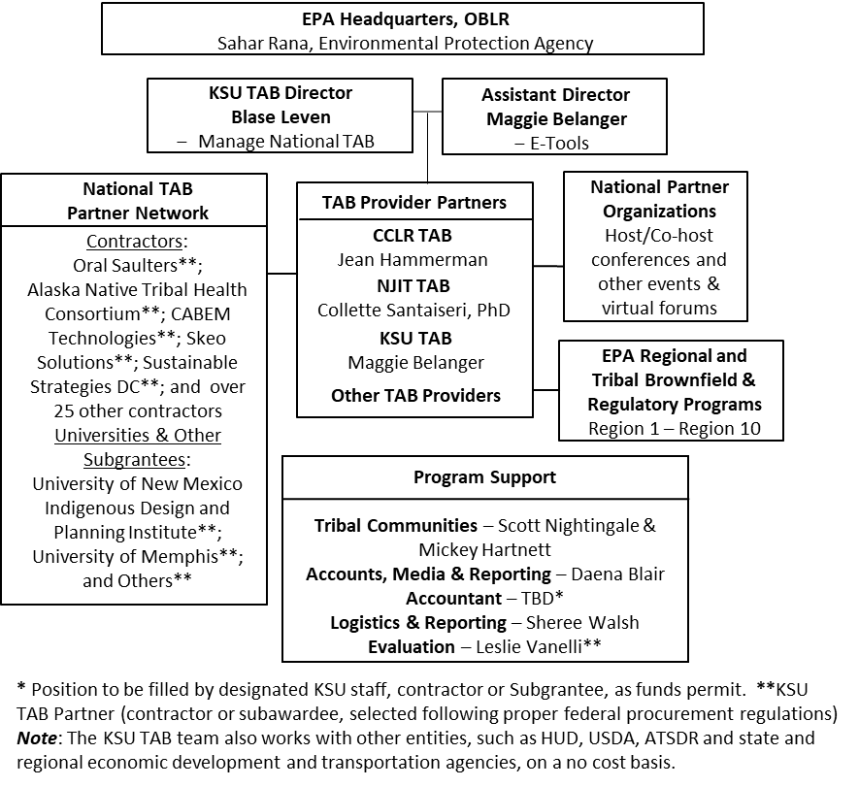

**------------------------------ Break in Content ---------------------------------**

**KSU Region 5 TAB Setup**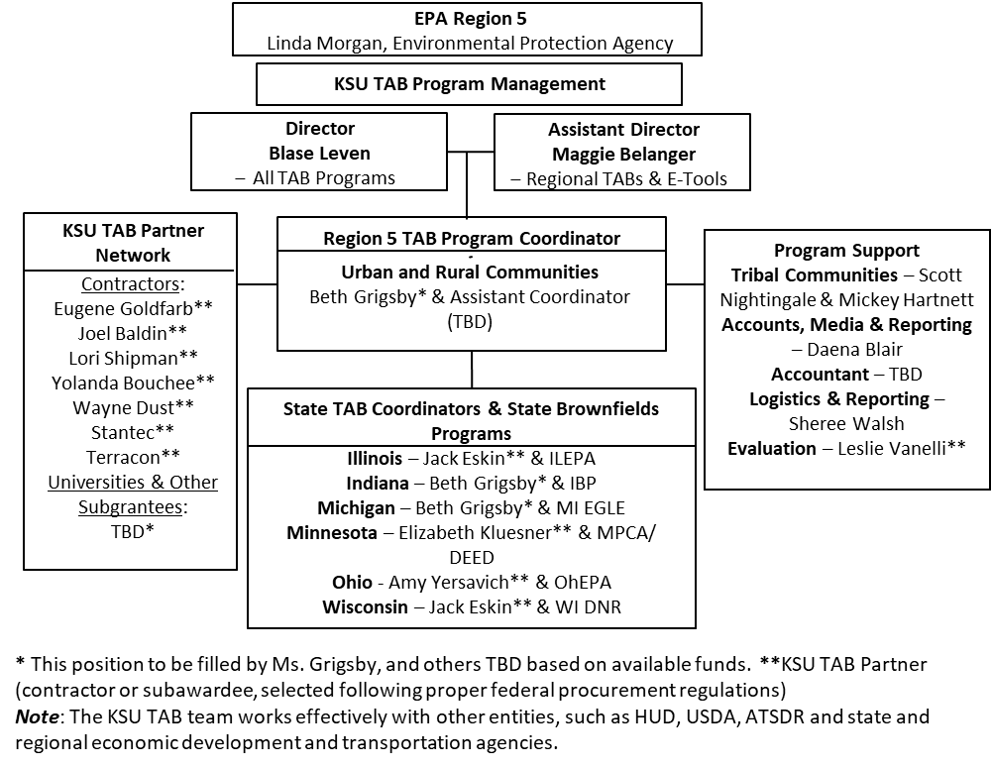

**------------------------------ Break in Content ---------------------------------**

**KSU Region 6 TAB Setup**

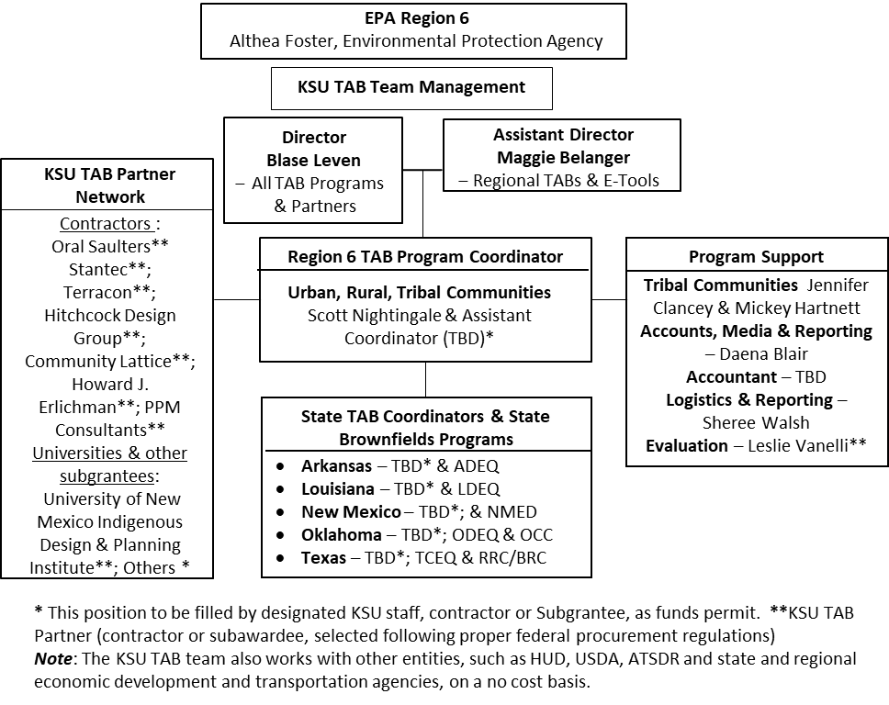

**------------------------------ Break in Content ---------------------------------**

**KSU Region 7 TAB Network**

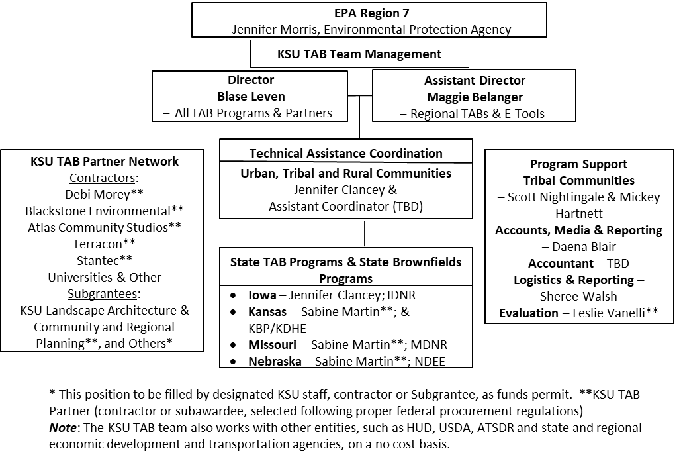

**------------------------------ Break in Content ---------------------------------**

**Figure 3e: KSU Region 8 TAB Network**

